Creating a Mobile game with a cust

## By Michael Shalaby

## Supervised by Keith Mannock Student ID: mshala02 Msc Computer Science Project Proposal

## 

Abstract:  
This proposal will outline the design requirements of to create a Physics Library for mobile game development using open source graphics libraries. The proposed library will be built using kotlin as the language of choice in order to specialise the physics library for android app development. In order to assess the viability of the physics library, the library will require a lot more than unit testing to see if it works. Therefore the ideal testing ground for this library would be to use it to simulate the daring dam-busters raid “Operation Chastise” carried out by the British during WW2.

### Disclaimer:

This proposal is substantially the result of my own work, expressed in my own words, except where explicitly indicated in the text. I give my permission for it to be submitted to the JISC Plagiarism Detection Service.

Contents

By Michael Shalaby 1

Supervised by Keith Mannock Student ID: mshala02 Msc Computer Science Project Proposal 1

Abstract: 1

Disclaimer: 1

Chapter 1. Introduction: 3

History of physical simulations in video games. 3

Why simulate Operation Chastise: 3

A brief history of operation chastise 3

What makes operation chastice the ideal testing ground for the physics library 4

4

4

Why build a new physics library for mobile apps 4

The physics Library Incorporate: 5

Road Map 5

Chapter 2: Background 6

Simulating motion 6

Basics of motion. 6

Circular motion 9

Collisions 10

Friction 10

Discussing lift through different means 10

Chapter 3: Analysis Requirements and Design 10

Language of choice 10

Design patterns 10

Implementing motion into code 10

Vectors 11

Chapter 4: Experimentation and Evaluation 11

Chapter 5: Timescale 11

# Chapter 1. Introduction:

In this section, the history and importance of physics libraries will be discussed with regards to how they relate to simulating the daring air raid, Operation chastise.

## 1.1 History of physical simulations in video games.

Since the introduction of video games in the 1970s, the first physics library came in the form of collision detection as seen in the game Pong (1972). Since then video game physics have seen a lot more development in recent years. These improvements vary by simulating variable motion in earlier racing games as demonstrated in pole position released 1982 to demonstrate how higher speed turning would lead to a larger turning radius to demonstrating the difference in driving on different surfaces like driving on tarmac then driving on grass or gravel.   
Over the following decades, more and more physical properties to video games became more and more mainstream. These would range from more simple applications like detecting collision between two separate objects and the transition from using ray tracing to simulate gun fire to implementing projectile motion to simulate the motion of a projectile like a bullet as travels through the air, calculating its new position at every iteration of time.

## 1.2: Why simulate Operation Chastise:

During my undergraduate studies in 2013, one of my projects was to build a web app to simulate some aspects of the bouncing bomb operation. However, due to having an extremely limited understanding in programming, the amount of physical properties that was simulated was very limited. However, as my understanding in programming has improved, so has my understanding on how to implement a more realistic simulation of a bouncing bomb by using less constants like having the velocity of the bomb along the i direction dynamically be affected by skimming the surface rather than a flat value of velocity reduced every time it skims.

### 1.2.1: A brief history of operation chastise

On the night of the 16th and 17th of May, the RAF launched one of the most daring bombing raids in World War 2. The objective of this raid was to destroy three dams located by the industrial heartland of Germany. The reason why dams were chosen in specific was because it was believed that by destroying the dams, it would flood the surrounding areas around the dam and prevent any electricity being generated by the dams. The idea behind this was that by destroying the dams, the British could cripple Germany’s industrial capabilities a lot more effectively than launching conventional bombing raids directly over the city. However, as every dam was protected by a series of torpedo nets, it was crucial for a new type of bomb that would skim over the water to avoid being caught by torpedo nets

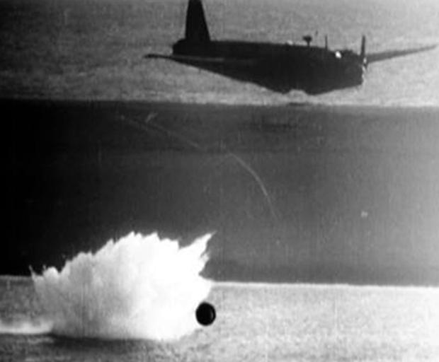

Image Depicting a test run of a bouncing bomb dropped by a wellington bomber. *Taken from* <https://www.helensburghadvertiser.co.uk/news/15475746.eye-on-millig-helensburghs-crucial-role-in-testing-dam-busters-bouncing-bombs/>

### 1.2.2: What makes operation chastice the ideal testing ground for the physics library

As the dam where protected by anti-torpedo nets. The bombs dropped where designed to bounce across the lakes in a similar manner to ‘skipping stones’. Thus, negating the effect of torpedo nets underwater. Therefore, this particular event provides many interesting physical aspects to simulate. This would include:

* The height in which the bomb is dropped. During the original operation, the plane was required to fly 60ft above the surface of the water. Therefore, the user can be given the option to adjust the height in which the bomb is dropped from.
* The rate in which the bomb was spinning. During the original operation, the bouncing bomb was required to have a back spin at 700 rpm. Although this did very little to affect the way the bomb hit the water, it seems more likely due to the Magnus effect caused by the rotation generating lift.
* As the bombs velocity is entirely dependant on the aircrafts velocity before it is launched, allow the user to adjust the aircrafts air speed to see how that will affect the characteristics of the bouncing bomb

## http://www.chm.bris.ac.uk/webprojects2001/moorcraft/Image25.gif

## 

Demonstration of how the bouncing bomb worked. Image taken from: <http://www.chm.bris.ac.uk/webprojects2001/moorcraft/The%20Bouncing%20Bomb.htm>

## 1.3: Why build a new physics library for mobile apps

While there are many excellent physics libraries available with a few being suitable for android app development including jbullet, a physics engine ported to java. There isn’t currently an existing physics library built with Kotlin. While java and kotlin both use the same compiler, the main issue java as a programming language face is the fact that it typically uses a lot more boilerplate code than kotlin.   
As kotlin has become considered to be the default language for android development since the release of android studio 3.0 has led to popular IDE’s like Jetbrain’s IntelliJ to utilise a kotlin to java converter to help developers reduce the amount of code they need to write and create less error prone programs for android in comparison to using Java.  
While Java is still being updated today with the latest release of Java 12. It is still considered by many to not be a fully modern programming language whereas kotlin is being viewed more and more as the successor to Java for android development.   
Another area of concern is that there isn’t really any physics library that can simulate the motion of a solid object skimming across a liquid surface which is the most important aspect to simulate for Operation Chastise

## 1.4 The physics Library Incorporate:

* Physics models
  + This would require the computation of a variety of physical aspects such as:
    - The initial position of an object in vector form (for 2d <i,j> for 3d <i, j, k>
    - The velocity of an object in vector form
    - The acceleration of an object (acceleration can be derived from the force exerted by an object and the mass assigned to an object which will be discussed in the forces in play)
    - Basic material properties necessary for simulation i.e. the density which will affect the mass of an object depending on its size)
* Objects manager
* Collision detection and response
  + The collision detection model should be able to determine which objects will collide with each other based on the geometry and position of each object
  + The collision response model should incorporate how objects would react when colliding i.e. is there two objects in motion colliding or is an object colliding with a static object, how much energy is lost as a result of collisions and how the rotation of an object would affect the way they respond (note that these will be two independent entities but the collision response is heavily dependent on collision detection)
* Force’s in play
  + The forces exerted by an object i.e. thrust generated from an aircraft
  + The forces exerted onto an object i.e. air and surface friction.

# 1.5 Road Map

This roadmap will explain the main areas of interest for the completion of this project.

* In chapter 2, the Background information relating to the mathematics behind real life physical phenomena would be derived and analysed
* In chapter 3, The analysis of different languages for Android applications will be discussed as with how to model physical properties into usable code to model a variety of aspects relating to Operation Chastice
* In chapter 4, The methods of testing the physics library would be discussed as well as how to test the Simulation of operation chastise.
* Chapter 5 will elaborate on how the production schedule of the library as well as detailing when certain aspects of the physics library will be completed and tested.

# 

# Chapter 2: Background

As this project relies almost entirely on physical equations and properties. This chapter would discuss the necessary equations needed to model motion, model collisions and collision response and the internal and external forces in play.   
While this proposal will only very briefly skim through these concepts. The Report will cover a lot more material on how each of these equations are derived.   
  
2.1: Simulating motion

One of the most important aspects of any physics library is to describe how objects in motion work. This can be derived almost entirely from first principle equations. This section will very briefly discuss how these will be derived from first principles and how these can be applied into very basic code with diagrams included.

## 2.2: Understanding motion.

In the simplest sense, an expression for an object in motion can be expressed using the following equations.

*Figure 3. Equations of motion*

Where:

* V = the velocity of an object at time t
* u = the initial velocity of an object
* s = the displacement of an object (in this case it’s the distance as vectors are not discussed yet)
* a = the acceleration of an object in motion
* t = the time (how long the object has been recorded in its motion)

Therefore, when plotting a graph of distance against time for an object with a constant velocity, a very obvious trend can be observed as demonstrated in figure 4.

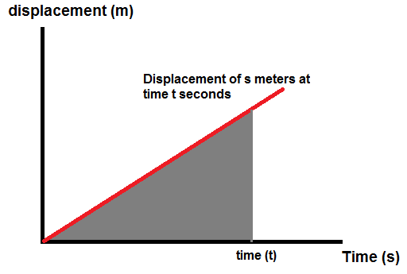

*Figure 4. displacement under a constant velocity plotted against time.*

Where the velocity can be observed as the gradient function of the change in displacement. Also, If a graph of the same constant velocity against time is plotted, another trend can be easily observed as follows.

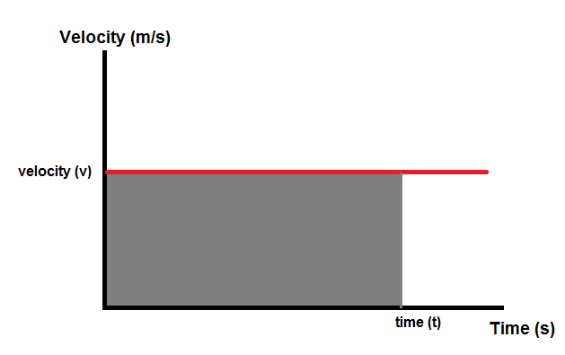

*Figure 5. constant velocity against time*

Where the total displacement of an object can be determined by calculating the area under the line. However, If the velocity is not constant but is increasing under a constant acceleration, The same trend observed in the displacement time graph can also be observed as follows.

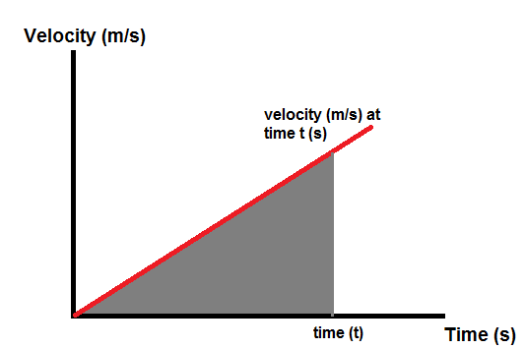

*Figure 6. velocity under constant acceleration against time*

From the graph in figure 6, the acceleration of the velocity can be derived from the gradient function of the graph. Much like the velocity can be derived from the gradient function of the graph depicting displacement against time.

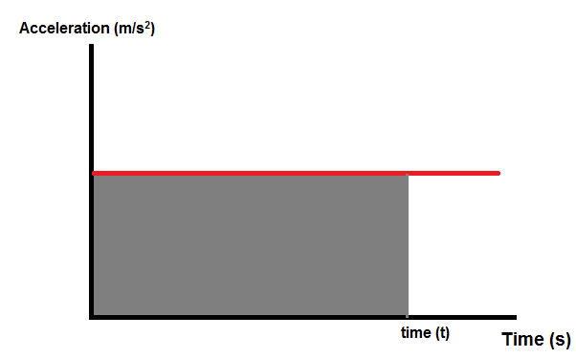Similarly to the previous examples, if a graph plotting acceleration against time is plotted as shown below:

*Figure 7. velocity under constant acceleration against time*

From this graph, the velocity can be derived in exactly the same way displacement was derived from the examples showing velocity against time graphs by calculating the area under the line.

Therefore, it can be observed that velocity is a measure of the rate of change of displacement against the rate of change against time and acceleration is the rate of change of velocity against the rate of change in time. Therefore, These relationships can be expressed in differential equations (equations that measure the rate of change in an instance infinitely small) as shown below in figure 8:

*Figure 8: velocity and acceleration expressed in differential equations.*

Also the velocity can also be measured from the area under the line of the acceleration/time graph as the displacement can be measured as the area under the line in the velocity/time graph. Therefore, these relationships can be expressed as integral equations (a measure of an area under a curve in iterations infinitely small).

*Figure 9: displacement and velocity expressed with integral equaitons with time t as the limit.*

Therefore, if the either the displacement, velocity or acceleration or all of them are non-uniform i.e. varying all the time, it will still be more than possible to get values for each of them in a given instance of time.

## 

## 2.3: Understanding Circular motion

While Circular motion is used to describe the rotation of an object rather than the movement of an object travelling from one point to another. The behaviour in which an object rotates can be expressed with almost identical equations to the equations of motions shown in figure 3 as demonstrated below:

*Figure 10: Equations for circular motion*

Note: all angles are assumed to be taken in radians unless expressed otherwise.

Where:

* = the angular velocity
* = the angle rotated
* = the angular acceleration
* t = time of rotation.

As seen in figure 3 in chapter 2.2, the equations for circular motion at the centre of a circle are identical to the equations of motion. Therefore, it can be assumed that the relationship between the angle rotated, the angular velocity and the angular acceleration would be also be identical to the relationship between the displacement of an object, the velocity of an object and the acceleration of an object in motion where:

Figure 11: using differential expressions to view the rate of change of circular motion

Figure 12: using integral expressions for circular motion

However the further away from the centre of rotation, the greater the velocity of travel. Therefore by examining some basic circle geometry as demonstrated in the diagram below

*Figure 13: Diagram showing a variety of aspects of a circle (Diagram created by the author)*

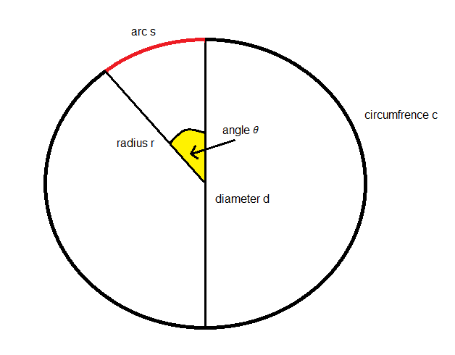

Diagram created by the author on paint

Where the circumference is calculated as follows on the circle is the total perimeter around the circle and can be calculated as follows:

*Figure 14: Equation for the circumference of a circle*

Where:

* d = the diameter of the circle (the total width of the circle)
* r = half the width of the circle
* c = the circumference of the circle (the total perimeter of the circle)

From the graph, it can be observed that the arc is a portion of the circumference. Therefore an expression for the arc can be derived from the ratio of the angle. Therefore the length of the arc can be expressed as follows

*Figure 15: deriving an expression for the arc*

Where:

* = angle traversed by the arc
* s = total length of the arc (this will later be known as the displacement traversing the circle as we move into circular motion. Hence why it shares the same variable name)

Therefore, if angular velocity is a measure of the rate of change of the angle rotated and the arc is a measure of a section of a circle rotated, an equation for the speed and acceleration around a circle can be shown as follows:

Figure 16: expressing velocity and acceleration on the circumfrence of a circle

# Forces, collisions and momentum

* Briefly explain:
  + Conservation of momentum
  + How inelastic collisions results in energy lost in other areas
    - Incorporate the co-efficient of restitution into the collison models
  + Incorporate non-linear collisions
    - How collisions at an angle can be calculated through the use of I and j vectors (or k vectors in 3d physics)

|  |  |  |
| --- | --- | --- |
| m1v1o - m2v2o | = | m1v1fcosθ1 + m2v2fcosθ2 |

## Friction

Discuss

* Surface friction
  + Fr = µR
    - Where
* Friction as a result of travelling through a medium (drag)
* D = Cd * A * .5 * r * V^2

## Discussing lift through different means

* Very briefly explain how lift works using the Bernoulli principle
* Very briefly incorporate this into the magnus effect
* Explain why this is important to the sim (as the bombs had backspin

# Chapter 3: Analysis Requirements and Design

This chapter will revolve around

## Language of choice

Discus the use of kotlin and why it is the most preferential choice for android development

* How it is the number one choice for android development as of recently
* Advantages over other languages like java
  + Kotlin is both a functional and object oriented language
  + Removes redundencies that may be present in java

## 

## Design patterns

Discuss the design patterns required for the development for the project

* Abstract factory: to implement similar objects that may have similar properties
* Adapter pattern: to adapt different objects that typically has similar behaviour
* Bridge pattern: to allow objects to be implemented independently

## Implementing motion into code

Explain how much of what we discussed in motion can be elaborated into vectors, matrices and the variable aspects of motion i.e. how the rate of change of displacement, velocity and acceleration can be expressed using more iterative equation like eulers method (with a degree of error) or

#### Libraries required

* Open gl
* Kotlin.math (obv)

### Vectors

* Through the use of vectors, the direction of motion can easily be achieved and analysed
* Can be broken down into two components, I and j vectors
* The resultant and angle can easily be determined for 2d, with 3d however, the resultant can still be easily determined

#### Linear motion

* Pretty much as discussed with the previous proposal but with vectors
* Remember everything is dependant on time

#### Circular motion

As computers lack the a

#### 

Where   
x and y is the original co-ordinates (in our case it will be I and j)  
x’ and y’ are the new co-ordinates



# Chapter 4: Experimentation and Evaluation

Discuss how are we going to test for various aspects of the library. This should include:

* Develop a variety of unit tests to ensure that the functions being written should return realistic values and to maintain a healthy test driven development cycle.
* As some as issues that will arise with the library may not be immediately obvious. From unit testing, discuss how other methods of testing (user testing from the programmer) would be necessary to identify any areas for concern and create more unit tests to optimise the library and the sim.

# Chapter 5: Timescale

# Glossary

s = the displacement of an object (how much has the position changed)

v = velocity of an object in motion

a = the acceleration of an object

t = time period

Fr = surface friction

D = Air resistance

Cd = co-efficient of drag

Cl = co-efficient of lift

ρ = density of an object

# Refrences

1. [Physics for Game Developers, 2nd Edition](https://learning.oreilly.com/library/view/physics-for-game/9781449361037/) by Bryan Bywalec; David M Bourg  
   (viewed from <https://learning.oreilly.com/library/view/physics-for-game/9781449361037/ch02.html>**)**
2. A summarised comparison of kotlin vs java  
   <https://www.konstantinfo.com/blog/kotlin-vs-java/>
3. History of the bouncing bomb operation

<http://www.dambusters.org.uk/the-dam-raids/the-bomb/the-bouncing-bomb/>

1. How the bouncing bomb worked  
   <http://www.chm.bris.ac.uk/webprojects2001/moorcraft/The%20Bouncing%20Bomb.htm>
2. Circular motion  
   <http://web.mit.edu/8.01t/www/materials/modules/chapter06.pdf>
3. Relation of rotation vector and angular velocity  
   <https://physics.stackexchange.com/questions/433102/relation-between-rotation-vector-derivative-and-angular-velocity-when-the-rotati?rq=1>
4. Circular motion equaitons  
   <https://www.khanacademy.org/science/ap-physics-1/ap-centripetal-force-and-gravitation/introduction-to-uniform-circular-motion-ap/a/circular-motion-basics-ap1>
5. Physical simulations computed  
   <https://www.falstad.com/mathphysics.html>
6. <https://gamedevelopment.tutsplus.com/tutorials/how-to-create-a-custom-2d-physics-engine-the-basics-and-impulse-resolution--gamedev-6331>
7. <https://www.toptal.com/game/video-game-physics-part-i-an-introduction-to-rigid-body-dynamics>
8. <https://pet.timetocode.org/>
9. <https://www.intmath.com/differential-equations/11-eulers-method-des.php>
10. <https://github.com/dbacinski/Design-Patterns-In-Kotlin/tree/master/patterns/src/test/kotlin>
11. <http://mathworld.wolfram.com/RotationMatrix.html>
12. <https://www.helensburghadvertiser.co.uk/news/15475746.eye-on-millig-helensburghs-crucial-role-in-testing-dam-busters-bouncing-bombs/> (bouncing bomb and bomber image)
13. https://www.alanzucconi.com/2016/02/10/tranfsormation-matrix/